1.Which of the following HTTP Status code means NOT MODIFIED, used to reduce network bandwidth usage in case of conditional GET requests?

ANS: 304

2. 2.Which header should be configured to tell the server XML is preferred over JSON?

ANS: Accept

3. Which of the following is not an HTTP method?

ANS: Create

4.  4. SoapUI can be used to do?

ANS :

 Only SOAP API testing

5. In SoapUI properties are available at which level?

ANS: Project

6. .What is the hierarchy in SoapUI Projects?

ANS: Project > Test Suite > Test Case > Test Step

7.

1. Verify that clicking on the browser back button after successful logout should not take the User to a logged-in mode

2. .Verify that there is a limit on the total number of unsuccessful login attempts (No. of invalid attempts should be based on business logic. Based on the business logic, User will be asked to enter the captcha and try again or user will be blocked)

3. Verify that the password is in encrypted form (masked format) when entered in the password field.

4. Verify the password can be copy-pasted. System shouldn’t allow users to copy paste password.

5. Verify that encrypted characters in the “Password” field should not allow deciphering if copied

6. Verify that the “Remember password” checkbox is unselected by default (depends on business logic, it may be selected or unselected)

7. Verify whether the login form is revealing any security information by viewing the page source

8. Verify that the login page is vulnerable to SQL injection.

9. Verify whether the user is still logged in after a series of actions such as sign-in, close the browser, and reopen the application.

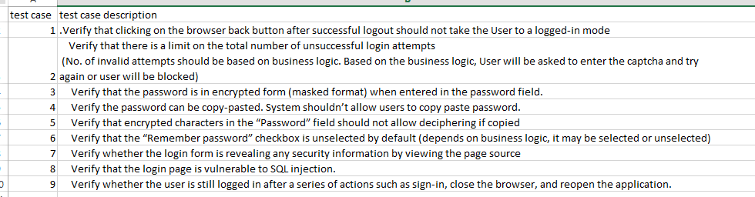

8. Which of the below element is used to check response validation?

ANS: Response assertion

9. Which of the below is error code?

ANS:      404

10. Which of the below tests is executed for extended no of hours ( ex: 8 hour):?

ANS:    Load test

11..Which of the following element is used to perform correlation?

ANS:    Regular expression extractor

12. Performance testing falls under which category?

ANS:      Non functional testing